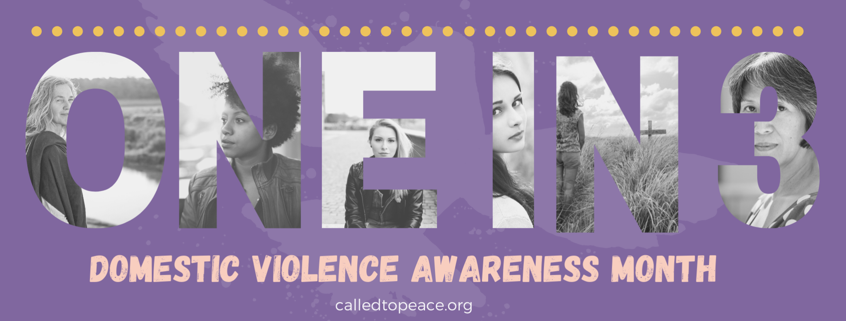

Sample Email Language:
As a church, we believe it is important to stand with the oppressed and care for the needy.
Psalm 82:4, “Rescue the weak and the needy; deliver them from the hand of the wicked.”
We partner with a local organization- Called to Peace Ministries. They work to provide hope and healing to victims of domestic abuse by offering a compassionate, comprehensive, and Christ-centered approach.

One woman in three reports having experienced some form of domestic violence (World Health Organization). October is Domestic Violence Awareness Month, and we would like to highlight their ministry and make sure you are aware that they are there as a resource to you. If you would like to learn more about domestic abuse or how to help, please check out their website.

Sample Announcement:
October is Domestic Violence Awareness Month. As a church, we want to be a community marked by justice and equality, giving voice to those oppressed or overlooked in various ways. In this way, we reflect the character of God in his concern for widows, orphans, and strangers.

Victims of domestic violence are often overlooked even by well-meaning churches who don't know what to do. It is my hope that, instead, we will be a safe haven for all who are oppressed by the evil of domestic abuse. To help us get there, we are partnering with an organization, Called to Peace Ministries that provides hope and healing to victims of domestic abuse by offering a compassionate, comprehensive, and Christ-centered approach. If you would like to learn more about domestic abuse or how you can get involved with their organization, check out their website calledtopeace.org.

